Ottawa County Department of Job & Family Services
8043 West State Route 163, Suite 200
Oak Harbor, Ohio 43449
Stephanie Kowal, Director

(419) 898-3688
(Located in Ottawa County Community Resource Centre) 1-800-665-1677
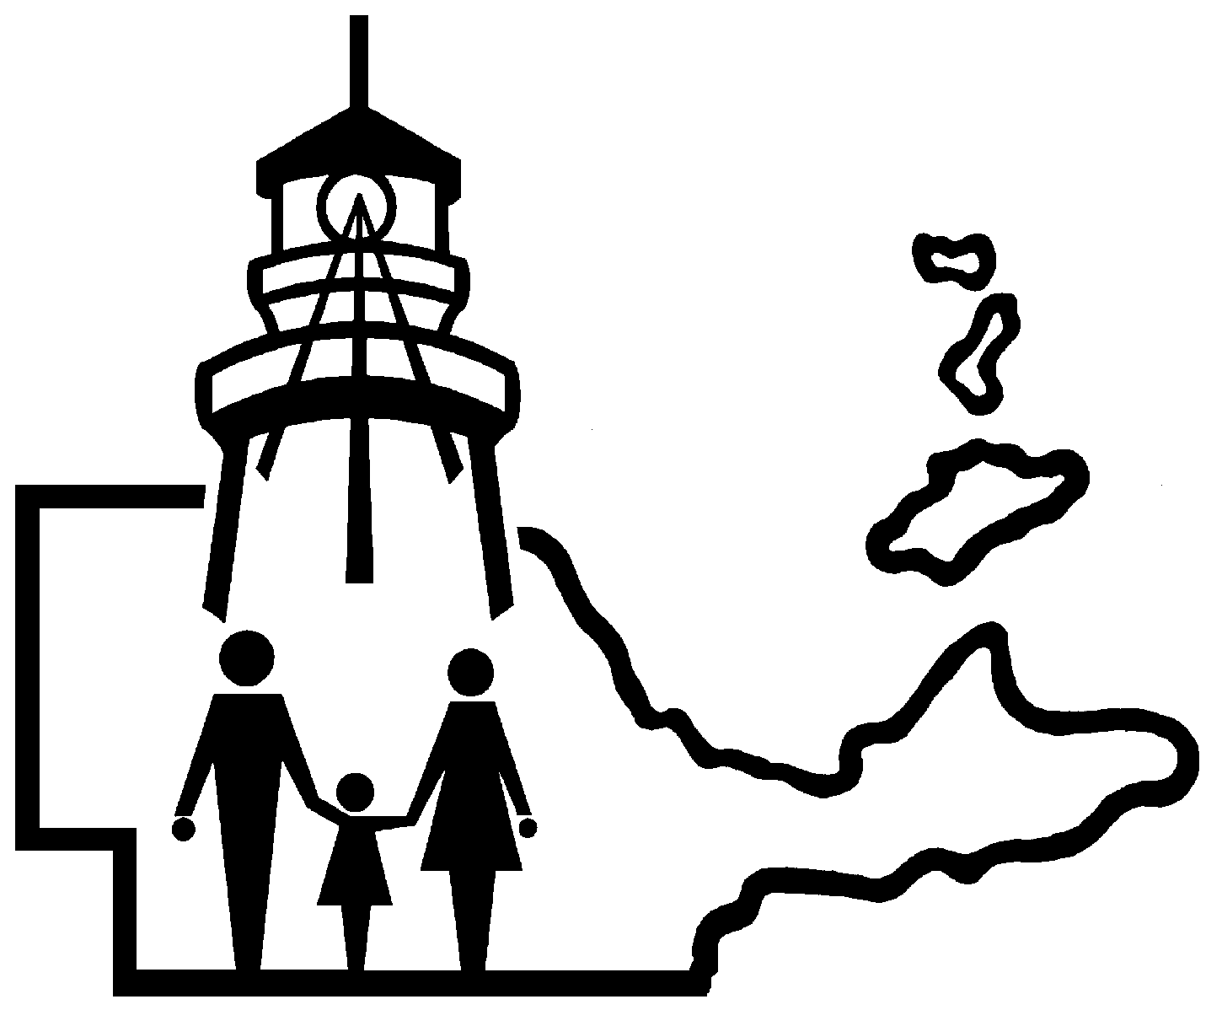
Limited Individual Payment Methods
March 16, 2020

CREDIT CARD PAYMENTS

- http://oh.smartchildsupport.com

- Discover, Mastercard, Visa, American Express, China Union Pay, Diners Club International, or JCB
- If the credit card is linked to an e-wallet account, can also use Alipay, Apple Pay, Google Pay, PayPal, and WeChatPay
- Can also process payments over the phone by calling your local child support office (419-898-3688) and speaking with your case manager, or calling 1-888-965-2676
- There are no fees attached to this transaction

- www.e-childspay.com

- MasterCard, Visa and Discover.
- The processor charges a fee of 2.95% of payment amount, with a maximum charge of $60.00 for all payments made on this site.
- Please allow seven (7) business days for the payment to be received by Ohio CSPC. The e-ChildsPay website has complete details about fees and the general use of the site.

ON-LINE PAYMENTS
- Pay by Checking Account Debit: Payment by checking/savings account debit can be made at www.expertpay.com. Please allow seven (7) days for the payment to be received by Ohio CSPC. FEES MAY APPLY. The ExpertPay web site has additional details about fees and the general use of the site.

MONEYGRAM

- Parents who owe child support now have the option to make payments in cash and in person at Walmart and CVS MoneyGram locations anywhere in Ohio. Ohio's Child Support Payment Central partnered with MoneyGram, a money transfer company with 40,000 locations in the U.S. and 350,000 worldwide. MoneyGram can electronically send payments to Ohio Child Support Payment. To pay, parents need their case ID and Cause or Docket number, Receive Code: 14674 and paying through MoneyGram charges an additional fee in addition to the payments. MoneyGram also has a mobile app that accepts payments. www.MoneyGram.com

PAYMENTS BY MAIL

- Your payment may be in the form of a personal check, money order, or cashier's check. Make checks payable to Ohio CSPC and mail via standard U.S. mail to:

Ohio CSPC
P.O. Box 182372
Columbus, OH 43218-2372

- CSPC accepts personal checks up to $20,000.If your support payment is for more than $20,000, you must send a certified check.
- Do not send payments to the County Child Support Enforcement Agency.
- If you need to send your payment via overnight delivery, you must use the United States Postal Service's Express Mail.

- Information That Must Be Included With Payments

- To ensure prompt and accurate posting to your child support case, please be sure to include the following with your payment:

- Your Name,
- Your Social Security Number (optional),
- SETS Case Number (10-digit number that begins with a 7),
- Court Order Number and
- Amount that should be applied to each case (if you have more than one case).

