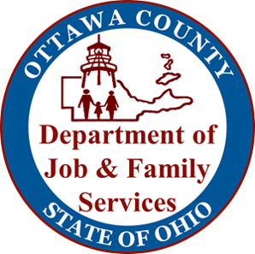
As part of the efforts to contain the spread of the COVID 19 virus and in consideration of the safety of our customers, staff and families, the Ottawa County Dept. of Job & Family Services and OhioMeansJobs Ottawa County will be CLOSED TO THE PUBLIC unless by appointment
effective Friday, May 1, 2020 until July 6, 2020.
Note: All visitors will be required to wear appropriate face covering while at Resource Centre.

The following services are still available by telephone and/or online:

PUBLIC ASSISTANCE PROGRAMS: www.benefits.ohio.gov, call (419)898-3688 or for SNAP, Cash and Medicaid, call 1-844-640-6446.

CHILD SUPPORT: www.jfs.ohio.gov/ocs/custservwebportalwelcome2.stm

CHILD & ADULT PROTECTIVE SERVICES: call 419-707-8639 to report suspected child or elder abuse

Documents for all programs can be placed in the agency drop box outside the main entrance or emailed to info@ottawacountyjfs.org
When emailing documents please provide a case number, name and phone number. This email box accepts documents for all programs in the building. Please do not leave cash or checks in this box.

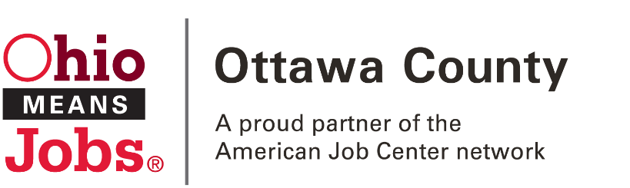
JOB SEARCHES: www.ohiomeansjobs.com
RESUME CREATION: www.ohiomeansjobs.com/ottawa
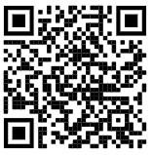
UNEMPLOYMENT INFORMATION: www.unemployment.ohio.gov or call toll-free at 1-877-644-6562
Please contact our office with any questions:
(419) 707-8605 OR (419) 707-8635
ASKOMJ@ocic.biz

